Technical Architecture
Architectural Diagram
The diagram below shows how requests flow from the client layer, through the Express.js application layer (routes, controllers, and JWT authentication middleware), down to the MongoDB Atlas database layer and out to the external Google Gemini AI service.
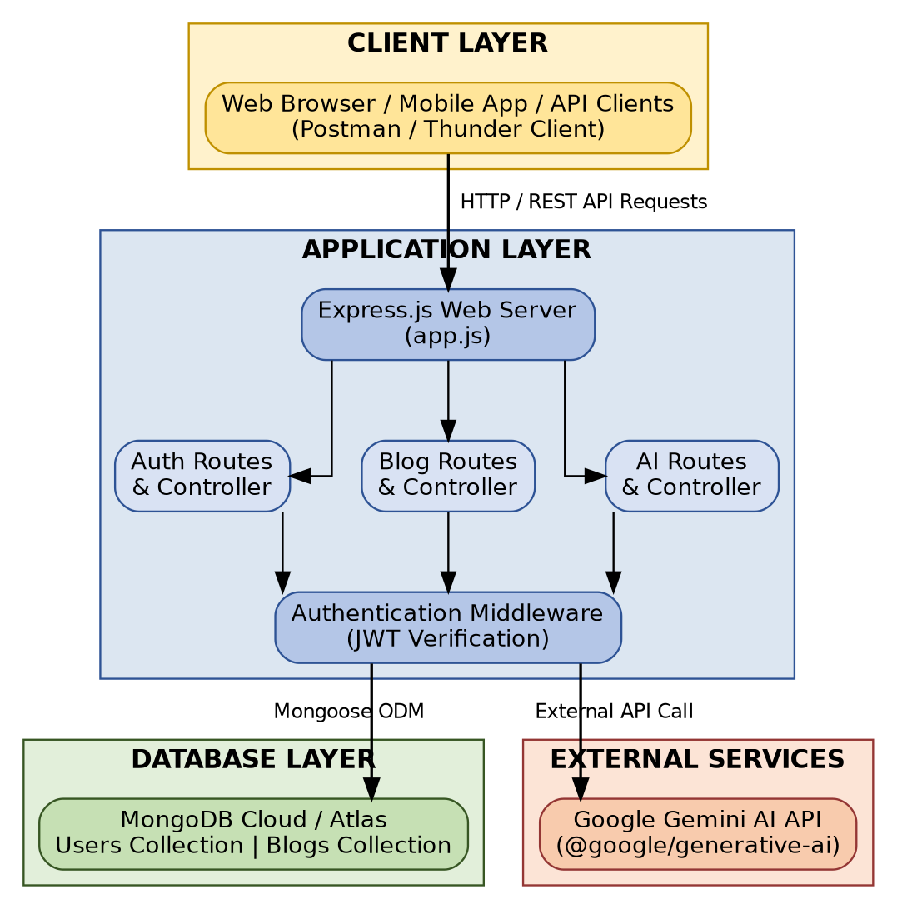
Figure 1: BlogNest Technical Architecture
Table-1: Components & Technologies
S.No | Component | Description | Technology
1 | User Interface | RESTful HTTP API clients, web frontends, or API testing platforms interacting with backend endpoints. | HTML5, CSS3, JavaScript / React.js / Postman / Thunder Client
2 | Application Logic-1 | Core backend web framework handling request routing, JSON parsing, dynamic error handling, and business processes. | Node.js (v18+) / Express.js (v4.21.2)
3 | Application Logic-2 | Authentication and security management including password hashing, JWT creation, verification middleware, and route protection. | JSON Web Token (jsonwebtoken v9.0.2) & bcryptjs (v2.4.3)
4 | Application Logic-3 | Content management engine handling CRUD operations for user profiles and blog posts with author population. | Node.js / Mongoose ODM (v8.10.0)
5 | Database | Document-oriented NoSQL database storing persistent records for application users and blog content. | MongoDB / NoSQL Data Store
6 | Cloud Database | Fully-managed MongoDB cloud service hosting database clusters for production deployments. | MongoDB Atlas
7 | File Storage | Storage for local application code, environment configuration files, dependency management, and logs. | Local File System / Node Environment (dotenv v16.4.7)
8 | External API-1 | Generative AI integration used for generating automatic blog posts, article summaries, and creative content. | Google Gemini API (@google/generative-ai v0.22.0)
9 | Infrastructure (Server / Cloud) | Local development environment using hot-reload monitors and cloud deployment platforms for Node.js services. | Local Node Server, nodemon (v3.1.9) / Render / Vercel
Table-2: Application Characteristics
S.No | Characteristics | Description | Technology
1 | Open-Source Frameworks | Express.js framework for server creation and modular routing; Mongoose ODM for object mapping and database schema validation. | Express.js, Mongoose, Node.js
2 | Security Implementations | Password encryption using bcryptjs salting and hashing; stateless bearer token authorization via JWT; environment secrets protection using dotenv. | bcryptjs, jsonwebtoken (JWT), HTTP Bearer Middleware, .env protection
3 | Scalable Architecture | Modular 3-tier RESTful architecture separating route controllers, business logic services, data models, and database persistence. | Express MVC / 3-Tier Architecture, MongoDB Atlas Scalable Clusters
4 | Availability | Asynchronous non-blocking I/O event loop execution in Node.js paired with cloud database replica sets for uninterrupted uptime. | Node.js Async Engine, MongoDB Atlas Multi-Region Replica Sets
5 | Performance | Fast JSON payload processing, indexing on MongoDB foreign keys (author field references), and centralized error handling middleware. | Node.js Event Loop, Mongoose Population & Indexing, Express Middleware

